We are pleased to offer you the convenient automatic option to pay your pharmacy statement by Direct Debit. When you sign up for our Direct Debit Payment Plan, the amount owing on your monthly pharmacy statement will be deducted electronically from your bank account on the 26th of each month. To take advantage of this ‘hassle free’ offer, please complete this for, attach a blank “void” cheque and return to the address noted below.

CUSTOMER NAME: | Pharmacy will complete this section:  Acct#: ________________________
FACILITY NAME:

BILLING/PAYOR INFORMATION

First Name: ______________________________ Last Name: ___________________________________

Billing Address: _________________________________________________________________________

City: ________________________________ Province: __________________ Postal Code: __________

Phone: _________________________________________________________________________________

BANKING INFORMATION (PLEASE ATTACH A VOID CHEQUE)

Transit #: ________________Institution#: __________ Account #: ______________________________
(5 digits) (3 digits) (as appears on cheque)

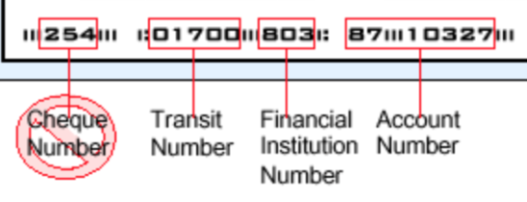

AUTHORIZATION: I/We authorize Lawtons Drugs Inc., (on behalf Sobeys National Pharmacy Group), to deduct payments monthly, in various amounts, for payment of charges for goods and services purchased from Sobeys National Pharmacy Group/We have read and understood the terms of this authorization and acknowledge receipt of a copy thereof. This authority is to remain in effect until Sobeys National Pharmacy Group has received written notification from me/us of its termination. This notification must be received at least ten (10) business days before the next debit is scheduled at the address provided above. I/We have certain recourse rights if any debit does not comply with this agreement. For example, I/We have the right to receive reimbursement for any PAD that is not authorized or not consistent with the PAD agreement.

Signature: _______________________________________ Date: _________________________________

To ensure your privacy and confidentiality, please return the completed form with a blank “void” cheque to: Sobeys National Pharmacy Group Attn: Lori Orgar 535 Portland St, Unit 1, Dartmouth, NS B2Y 4B1 Should you have any questions, please contact Lori at
902 468 1000 extension 8643

